**SQL QUERIES ----------------------------------------------------------------PYTHON QUERIES**

**🡪Select * from dataset_1** **🡪 data**

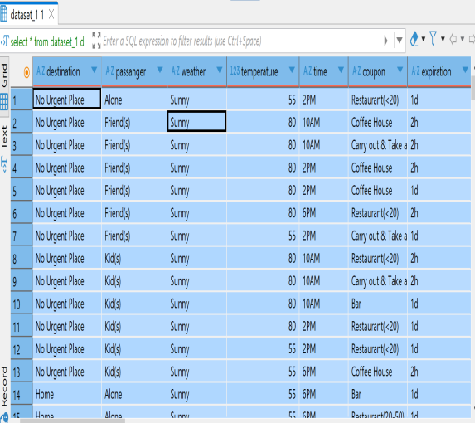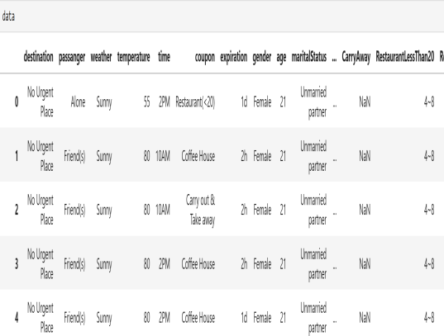

**🡪select weather,temperature from dataset_1 🡪data[[‘weather’,’temperature’]]**

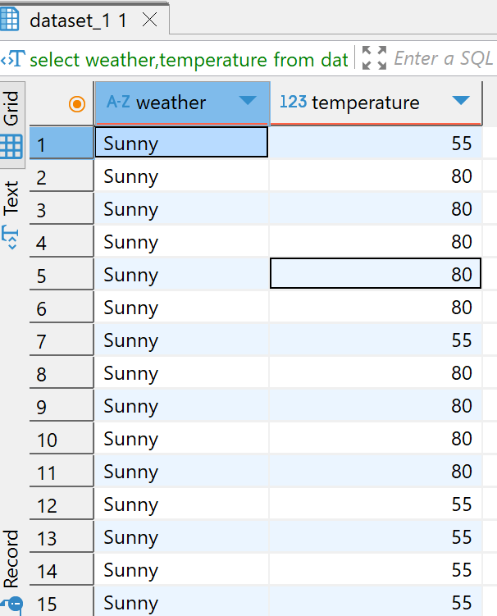 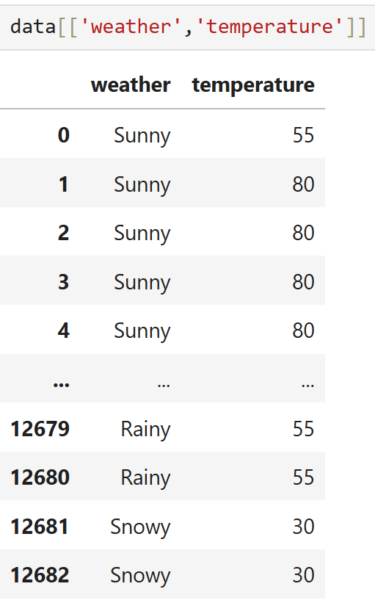

**🡪 select * from dataset_1 limit 10; 🡪data.head(10)**

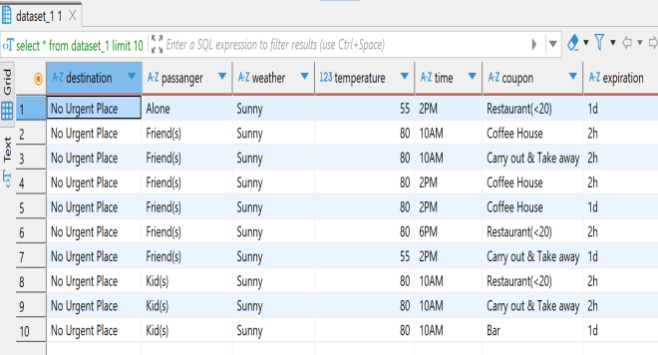 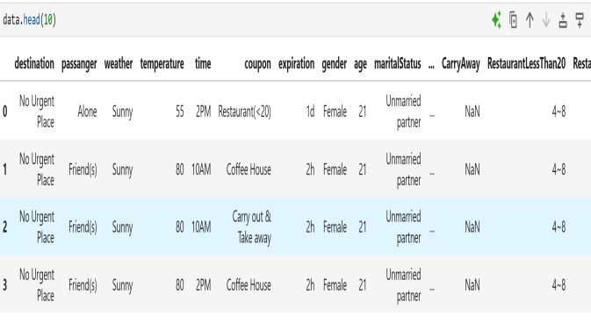

**🡪 select DISTINCT passanger from dataset_1; 🡪 data['passanger'].unique()**

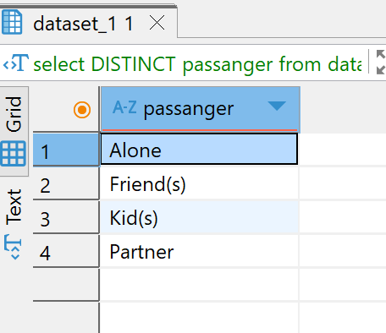 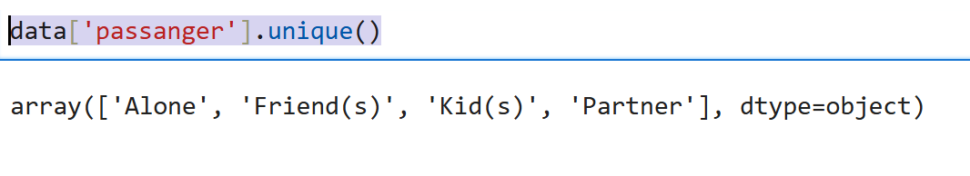

**🡪Select * from dataset_1 where destination=’home’; 🡪 data[data['destination']=='Home']**

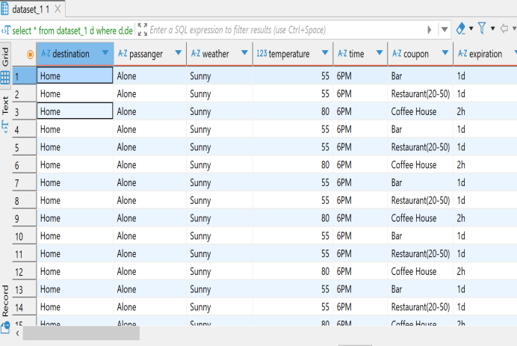 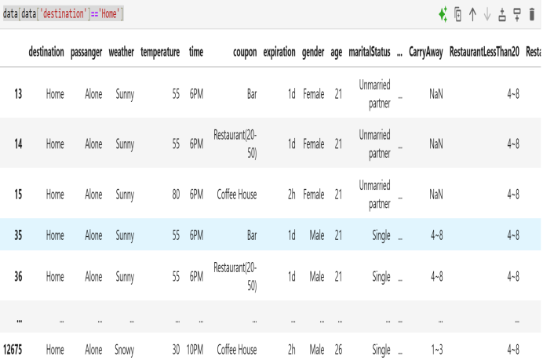

**🡪 select * from dataset_1 order by coupon ; 🡪data.sort_values(‘coupon’)**

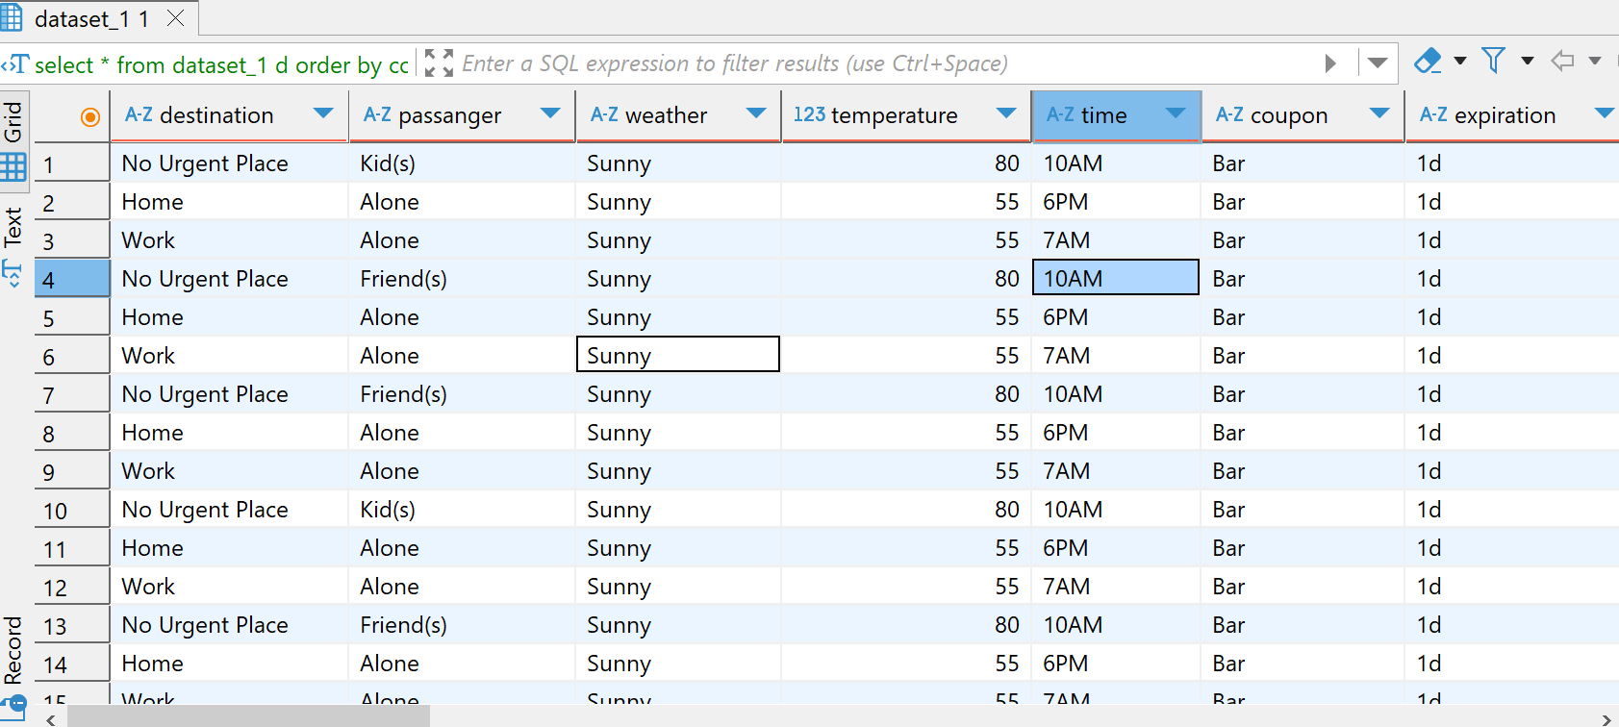 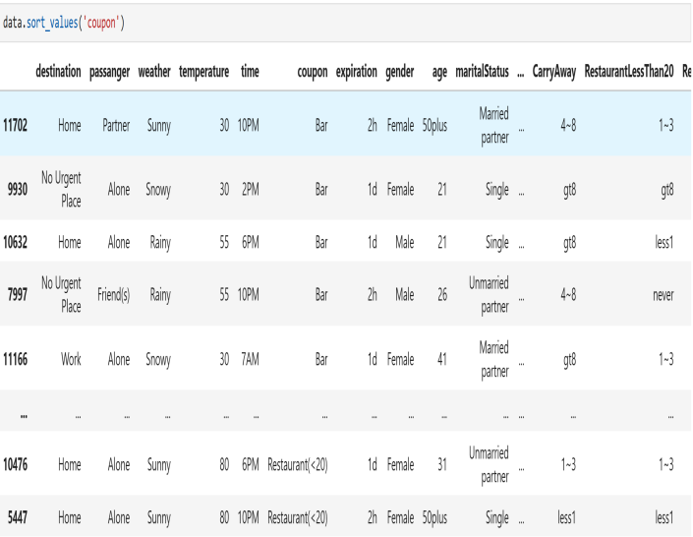

**SQL QUERIES**

**🡪 select destination as Destination from dataset_1;**

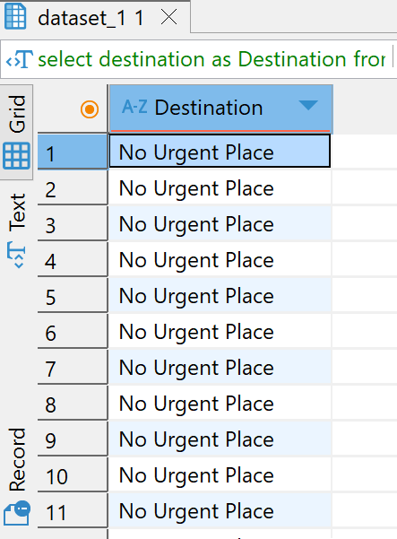

**PYTHON QUERIES**

* **data.rename(columns={'destination':'Destination'})**

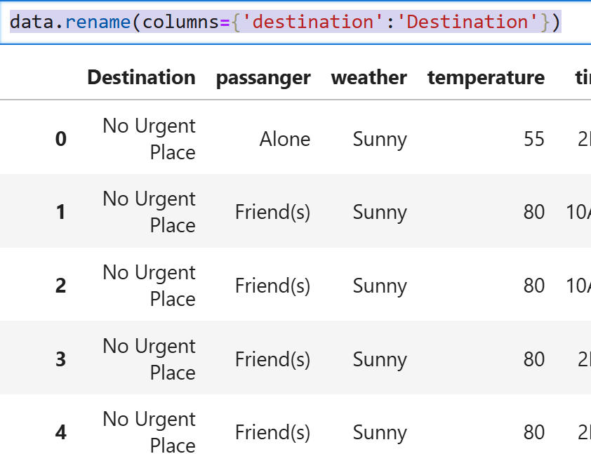

**SQL QUERIES**

**🡪select occupation from dataset_1 group by occupation ;**

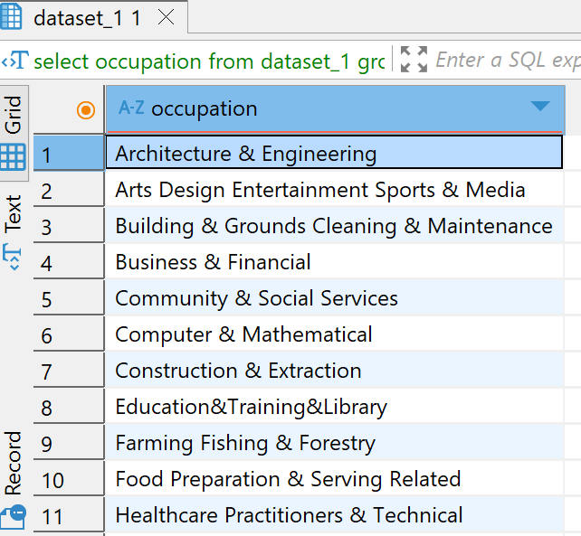

**PYTHON QUERIES**

**🡪sorted(data['occupation'].dropna().unique()**



**SQL QUERIES**

* **select weather,AVG(temperature) as avg_temp from dataset_1 group by weather ;**

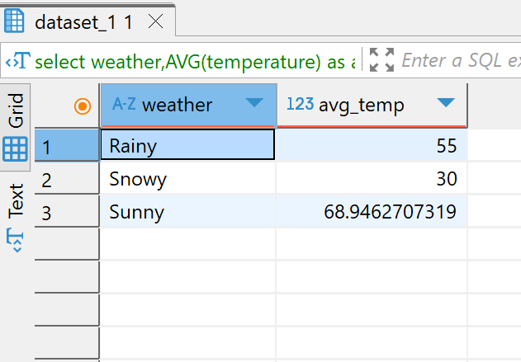

**PYTHON QUERIES**

* **data.groupby('weather')['temperature'].mean().to_frame('avg_temp').reset_index()**

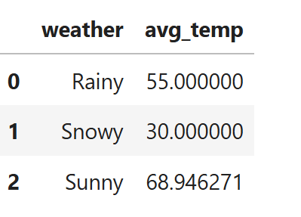

**SQL QUERIES**

* **select weather,count(temperature) as count_temp from dataset_1 group by weather ;**

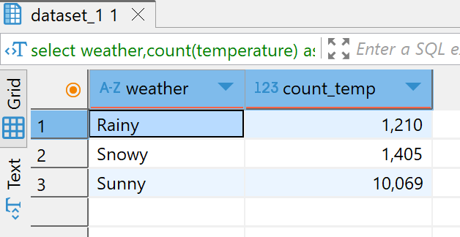

**PYTHON QUERIES**

* **data.groupby('weather')['temperature'].count().to_frame('count_temp').reset_index()**

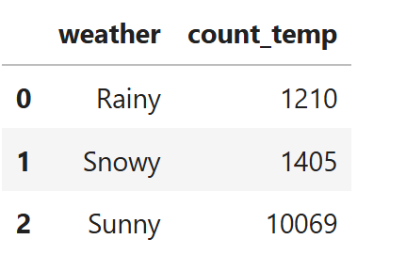

**SQL QUERIES**

* **select weather,count(DISTINCT temperature) as count_temp from dataset_1 group by weather ;**

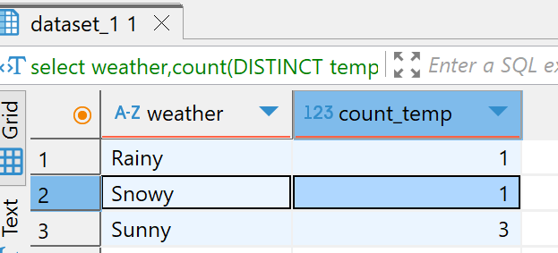

**PYTHON QUERIES**

* **data.groupby('weather')['temperature'].nunique().to_frame('distnict_count_temp').reset_index()**

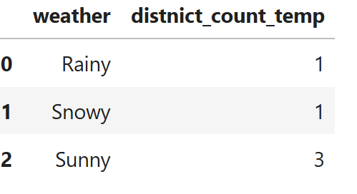

**SQL QUERIES**

* **select weather,sum(temperature) as count_temp from dataset_1 group by weather ;**

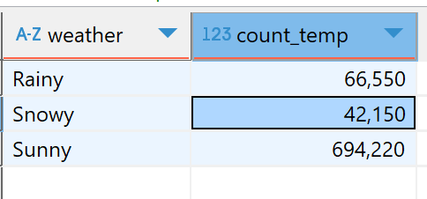

**PYTHON QUERIES**

* **data.groupby('weather')['temperature'].sum().to_frame('sum_temp').reset_index()**

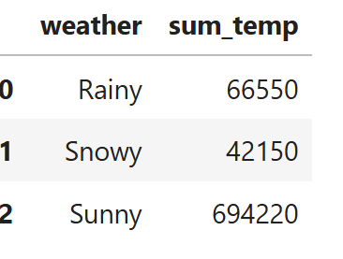

**SQL QUERIES**

* **select weather,min(temperature) as min_temp from dataset_1 group by weather ;**

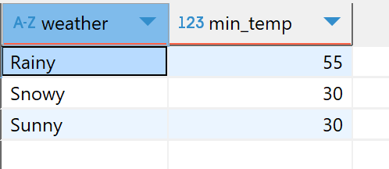

**PYTHON QUERIES**

* **data.groupby('weather')['temperature'].min().to_frame('min_temp').reset_index()**

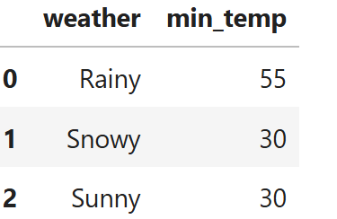

**SQL QUERIES**

* **select weather,max(temperature) as max_temp from dataset_1 group by weather ;**

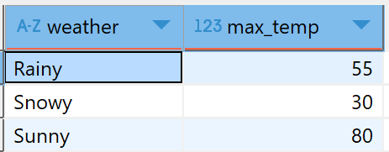

**PYTHON QUERIES**

* **data.groupby('weather')['temperature'].max().to_frame('max_temp').reset_index()**

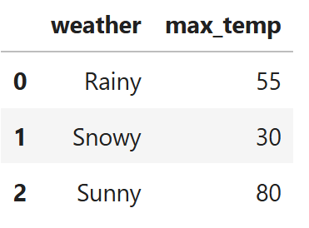

**SQL QUERIES**

* **select occupation from dataset_1 group by occupation HAVING occupation='Student';**

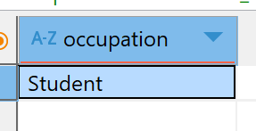

**PYTHON QUERIES**

* **data.groupby('occupation').filter(lambda x: x['occupation'].iloc[0] ==**

**'Student').groupby('occupation').size()**

**(OR)**

* **data[data['occupation'] == 'Student'].groupby('occupation').size()**

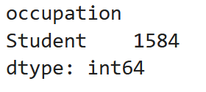

**SQL QUERIES**

* **SELECT DISTINCT destination FROM(SELECT * FROM dataset_1 UNION SELECT * FROM table_to_union)**

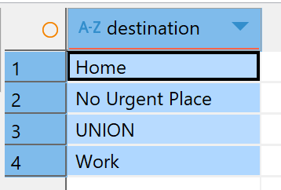

**PYTHON QUERIES**

* **pd.concat([data, table_to_union])['destination'].drop_duplicates()**



**SQL QUERIES (Inner join )**

* **select a.destination ,a.time,b.part_of_day from dataset_1 a inner join table_to_join b on a.time =b.time;**

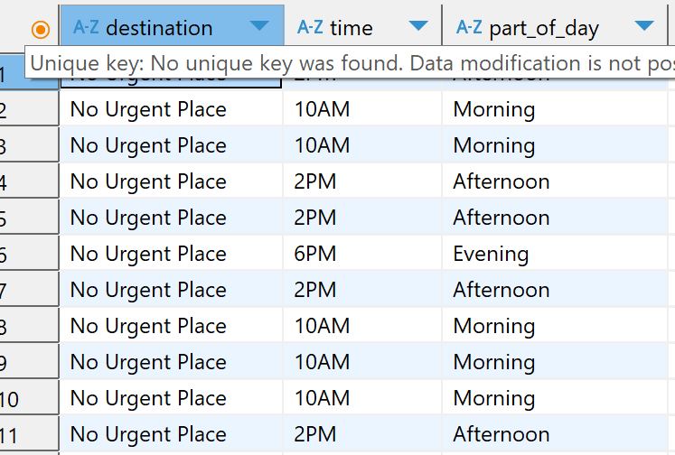

**PYTHON QUERIES**

* **pd.merge(data,table_to_join[['time','part_of_day']],on='time',how='inner')[['destination','time','part_of_day']]**

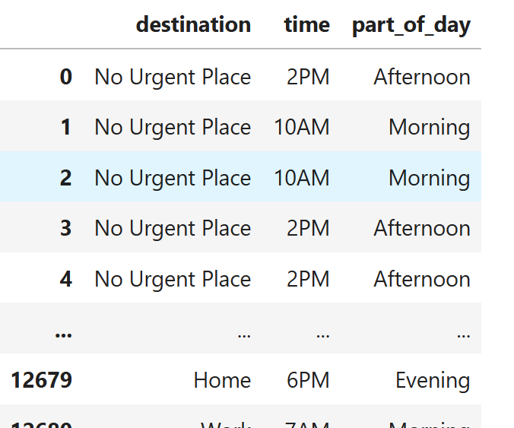

**SQL QUERIES**

* **select destination,passanger from (select * from dataset_1 where passanger ='Alone');**

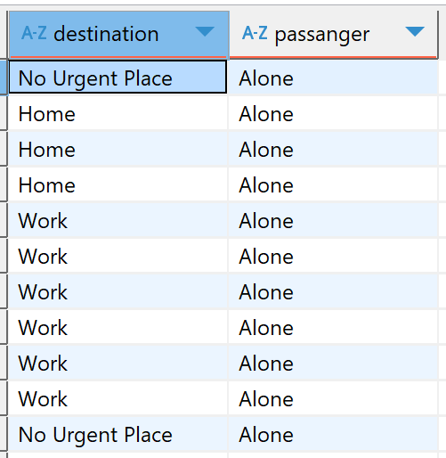

**PYTHON QUERIES**

* **data[data['passanger']=='Alone'][['destination','passanger']]**

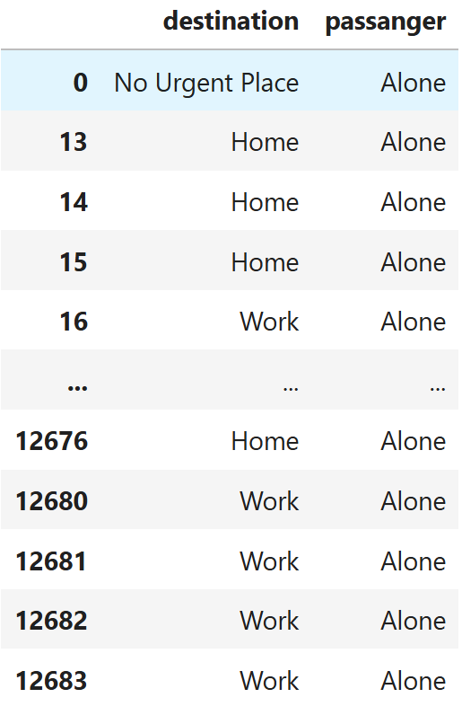

**SQL QUERIES**

* **select * from dataset_1 d where d.weather like 'Sun%';**

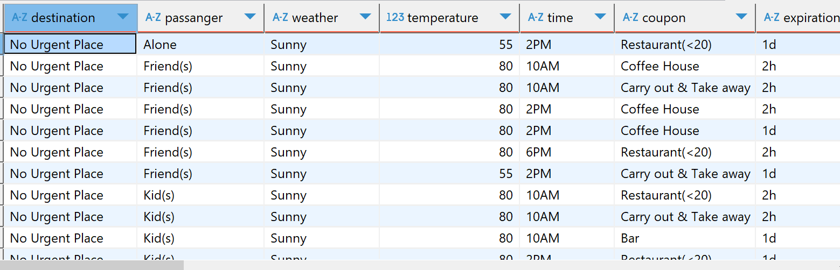

**PYTHON QUERIES**

* **data[data['weather'].str.startswith('Sun')]**

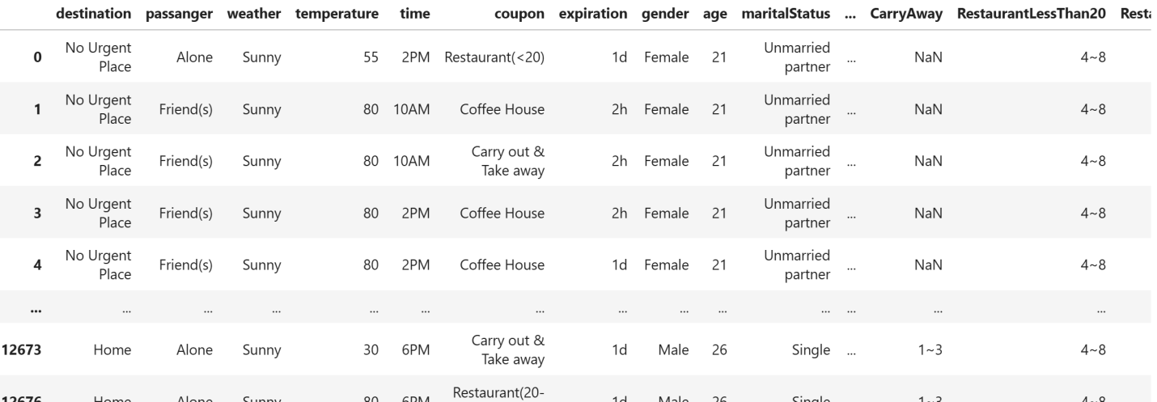

**SQL QUERIES**

* **select DISTINCT temperature from dataset_1 where temperature between 29 and 75;**

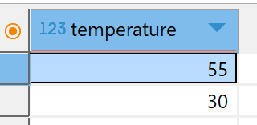

**PYTHON QUERIES**

* **data[(data['temperature']>=29) & (data['temperature']<=75)]['temperature'].unique()**



**SQL QUERIES**

* **select occupation from dataset_1 where occupation in('Sales & Related','Management');**



**PYTHON QUERIES**

* **data[data['occupation'].isin(['Sales & Related','Management'])][['occupation']]**

